6. Alphabet game

Worksheet 6

Notes for the teacher: For students with a light mental handicap it’s not so easy to concentrate for longer periods of times. Therefore it’s important to include some shorter and easier in between exercises. This alphabet exercise allows them to relax and work by themselves. They look for words that have something to do with this lesson. They write them first in English, then in their mother tongue and then in any other language they might know. Only in English the word have to start with the letters from the alphabet. The teacher provides worksheet 1 for every student.

Timing: 30’

Grouping: 

Focus on content:
- It can be a repetition of what they have learned during this lesson

Focus on languages:
- Interact in English (improve listening and speaking)
- Improve reading and writing in English
- Learn about similarities and differences between languages
- Value the diversity of languages
- Use different strategies to understand foreign languages
- Comparing different writing systems

Learner worksheet 1:

Try to make a word with every letter of the alphabet. The words must have something to do with this lesson about chocolate. Translate this word into your mother tongue and in another language you know.
English | Your mothertongue | Another language
A____________________ | ____________________ | ____________________
B____________________ | ____________________ | ____________________
C____________________ | ____________________ | ____________________
D____________________ | ____________________ | ____________________
E____________________ | ____________________ | ____________________
F____________________ | ____________________ | ____________________
G____________________ | ____________________ | ____________________
H____________________ | ____________________ | ____________________
I____________________ | ____________________ | ____________________
J____________________ | ____________________ | ____________________
K____________________ | ____________________ | ____________________
L____________________ | ____________________ | ____________________
M____________________ | ____________________ | ____________________
N____________________ | ____________________ | ____________________
O____________________ | ____________________ | ____________________
P____________________ | ____________________ | ____________________
Q____________________ | ____________________ | ____________________
R____________________ | ____________________ | ____________________
S____________________ | ____________________ | ____________________
T____________________ | ____________________ | ____________________
U____________________ | ____________________ | ____________________
V____________________ | ____________________ | ____________________
W____________________ | ____________________ | ____________________
X____________________ | ____________________ | ____________________
Y____________________ | ____________________ | 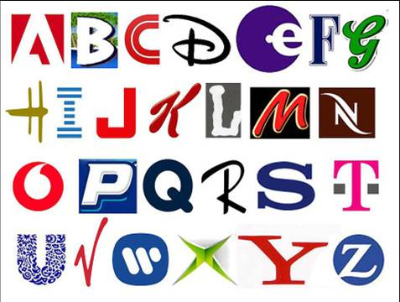  ____________________
Z____________________ | ____________________ | ____________________

Assessment :
- The students compare the languages of the class.
- Do they resemble or not?
- Can they understand them?

